1. ------------------------------------------------------

My name: Ngoc Hai Nguyen

Student number: 7548953

Email address: [nhn019@uowmail.edu.au](mailto:nhn019@uowmail.edu.au)

Assignment number: 03

List of files:

* One file to connect database: connectDB.php
* The first 2 page is: Login.php and Register.php.
* The 2 main homepages:
* Administrator.php:
* Renter.php
* Two classes: classCar.php and classUser.php
* In classUser.php, I created 2 functions (methods): One function was used write new users to the database, which was called in the register.php file. The other function is checkPassword, which is used in Login page.
* In classCar.php, there are a lot of function have been created, some functions is used for renter and some used for administrator. List of functions in class Car:
* Insert Car
* getAllCar: used to display all the cars.
* searchCar: functions for searching cars.
* changeCarStatus: Function for admins to change their cars’ status.
* listAllAvailableCars(): Function to display every available Car

Admin Sites:

* File insertNewCar.php: to get user input, call function insertCar and return to admin’s homepage.
* File changeStatusOfCar.php: to get user input, call function changeCarStatus and return to admin’s homepage.
* File searchCar.php: to get user input, call function searchCar and display result.

User Sites:

When user click display available Car, it will display all available car in the system and a rent button for user to click on.

* File rentCarContractForm.php: a form to get user input about indication of the length of the renting, return date and overall costs
* File writingRentalCarContract.php: write the rental contract information to the database.
* The last file is logout.php. This file is used to log out and return to the login page.

1. Databases

My database is composed of 3 tables: User, Car, and rentals.

* Table User has 5 attributes: ID, Name, Surname, Phone, Email, Password and Type of User.

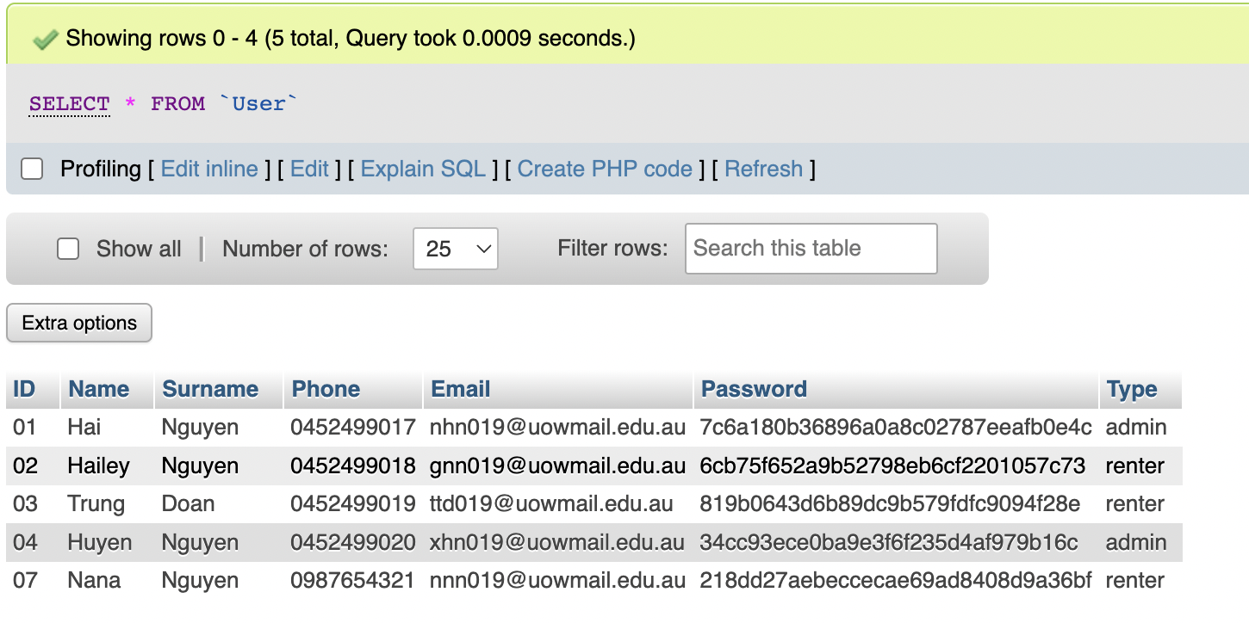

* Table Car has 6 columns: CarNo, Plates, Model, Type, Status, and CostPerDay.

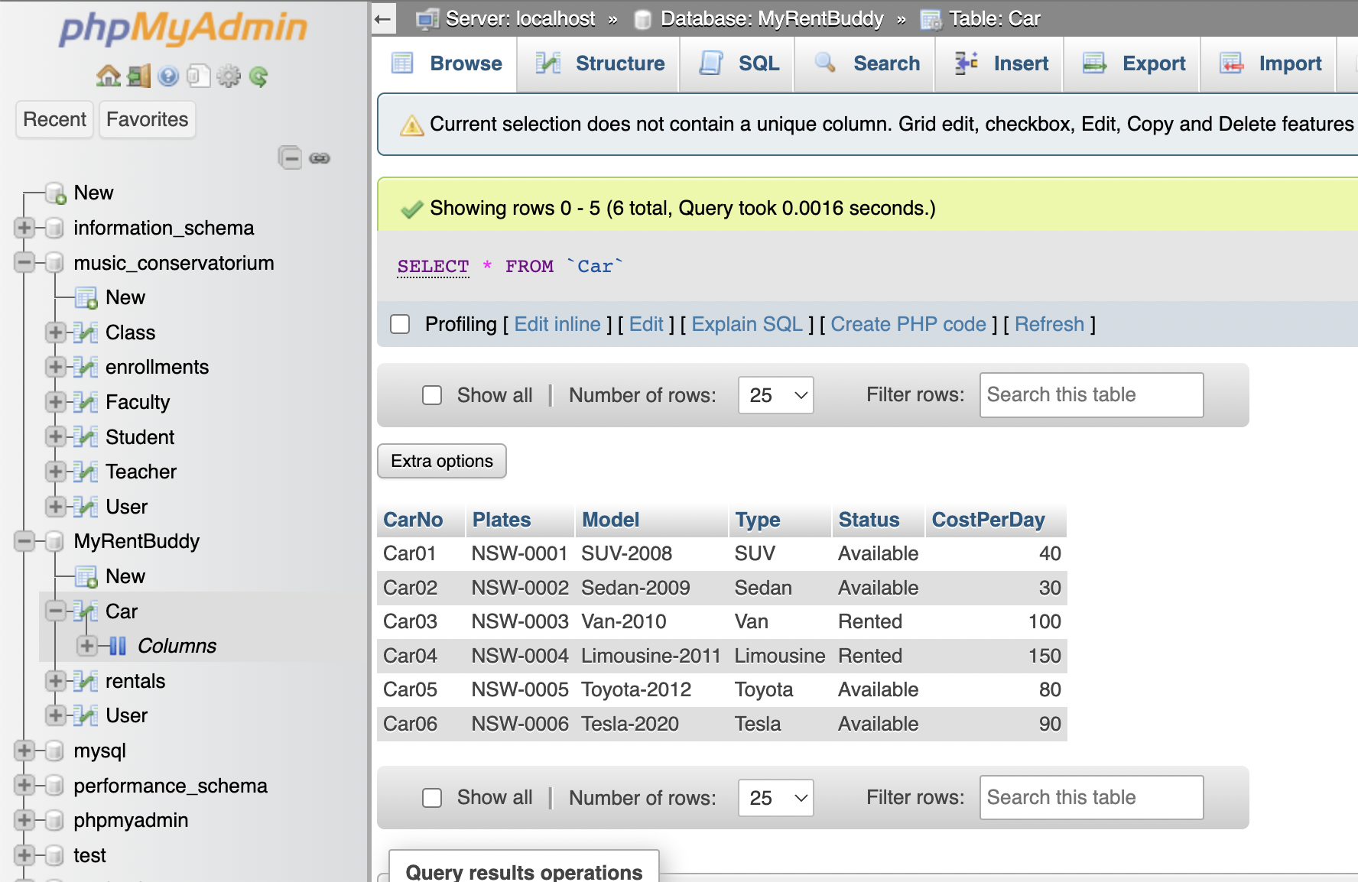

* The last table is User, which consists of 6 columns: Rental ID, Car ID, renter name, length of renting(day), return date and price 